**Advanced Security 2 - Assignment 1 – 15%**

**Jake Bolger**

**C18395341**

**Part A**

**In this assignment you will be required to research on the skills, certifications and training you will require to be a security expert. List your findings in one or two pages. Hint: start by looking at security job advertisements and reports such as http://goo.gl/c5zikq and** [**http://goo.gl/4s5aAe**](http://goo.gl/4s5aAe)**?**

Skills research

An aptitude for computers is possibly the number one quality of a cyber security expert. Other key skills and qualities include:

* In-depth knowledge of computer operating systems, hardware and software.
* First-class problem-solving skills.
* A strong ability to work well under pressure.
* Solid telecommunications knowledge.
* Rigorous attention to detail.
* persistence and determination.
* Excellent abilities in mathematics.
* Technical Aptitude.
* Knowledge of Security Across Various Platforms. ...
* Communication Skills.
* Fundamental Computer Forensics Skills.
* A Desire to Learn.
* An Understanding of Hacking.

Certifications and Training

1. Certified Information Systems Security Professional (CISSP):

A CISSP designs, implements, manages, and controls the architecture, design, or management of business environments for security.

2. Certified Information Systems Auditor (CISA):

In the IT community, the CISA certification is regarded as the gold standard, and it will make you stand out from the crowd. Obtaining and maintaining CISA certification requires a high level of commitment. It demonstrates your intelligence and ambition, both qualities needed for leadership roles.

3. Certified Information Security Manager (CISM):

Certificate in Information Security Governance. Information Risk Management. Information Security Program Development & Management. Information Security Incident Management.

4. Security+:

# Certification validates the skills required for core security functions and for pursuing a career in IT security.

5. Certified Ethical Hacker (CEH):

To earn the title of Certified Ethical Hacker, you need to demonstrate knowledge of evaluating computer security by looking for weaknesses and vulnerabilities in the target system.

6. GIAC Security Essentials Certification (GSEC):

Through the GIAC Security Essentials certification, practitioners demonstrate a depth of understanding of information security beyond simple concepts and terminology. By holding the GSEC certification, participants demonstrate their ability to perform hands-on security tasks related to IT systems.

7. Systems Security Certified Practitioner (SSCP):

For IT professionals with practical, hands-on security knowledge in operational roles, the Systems Security Certified Practitioner (SSCP) certification is the ideal certification. ... Security Operations and Administration. Access Controls. Risk Identification, Monitoring, and Analysis.

8. CompTIA Advanced Security Practitioner (CASP+):

The CASP+ certification covers security architecture, senior security engineering, governance, risk management, and compliance skills, testing enterprises for cybersecurity readiness, and leading technical teams to implement cybersecurity.

9. GIAC Certified Incident Handler (GCIH)

With a GIAC Incident Handler certification, you can demonstrate your proficiency in detecting, responding, and resolving computer security incidents using a wide range of skills.

10. Offensive Security Certified Professional (OSCP):

It teaches ethical hacking methodologies, as well as how to use the tools included with Kali Linux, which is an ethical hacking certification offered by Offensive Security

**Discuss why there is a shortage of security personnel worldwide.**

Now a days there are a variety of reasons why there is a shortage of security personnel worldwide. These reasons are as follows: lack of corporate security programs, underfunded security resources, lack of good tools and protocols, not enough security patches, not enough email security practices and finally people who don’t follow the policies of their company in security. Other reasons are the lack of interest from younger generations, increased number of attacks and not enough skilled defenders.

**What measures/actions should be taken to address this shortage?**

The measures that should be taken to address this shortage of security personnel are, to hire managed security service providers where your in-house talent is lacking and make sure their expertise matches your compliance requirements.

Provide detailed, enticing descriptions of each role when recruiting.

Teaching students should be done through real life scenarios.

Develop apprenticeships to recruit and prepare future employees. Some states offer tax credits to employers who hire apprentices. Support unique training exercises. IBM has developed mobile cybersecurity ranges help college students and professional practice responding to attacks.

Support mental health and wellness initiatives.

The last on is invest in employee training and certification. 93% of employees would stay at a company longer if it invested in their career.

**Do you think you have enough skills to be a security expert? If no, what are you missing and if yes what are your strengths?**

No, although I have a basic understanding of security, I am no expert. I have previous experience from college including different security techniques and cyphers, encryption, decryption, and penetration testing. I am missing a lot of manual knowledge and physical experience in security. In order to become an expert, I will certainly need to get real life experience in a job or company.

**Part B**

**In this part, you will be required to test and identify security flaws using any two static code analysis tools such as https://goo.gl/VvlkFj. While these tools do not provide 100% guarantee, they can identify most of the security flaws. Use one programs from your labs or assignments you did in third or fourth year. The submission in this part will be a list of identified security flaws in the code.**

The first static code analysis tool that I used is called ‘Guardrails’ which allows me to scan my work for errors and adjust my workflow. This was used to identify security flaws in my code from my games engines assignment I did. I installed this tool on my GitHub account and then scanned for flaws as shown below:

The flaws that were found are as follows:

The second tool I used was a tool called ‘DeepSource’. Again I linked it with my GitHub account and used my repositories to scan for security flaws.

In the codebase report there were a few issues such as performance issues, documentation issues, bug risks, and anti-patterns. There was 150 active issues.

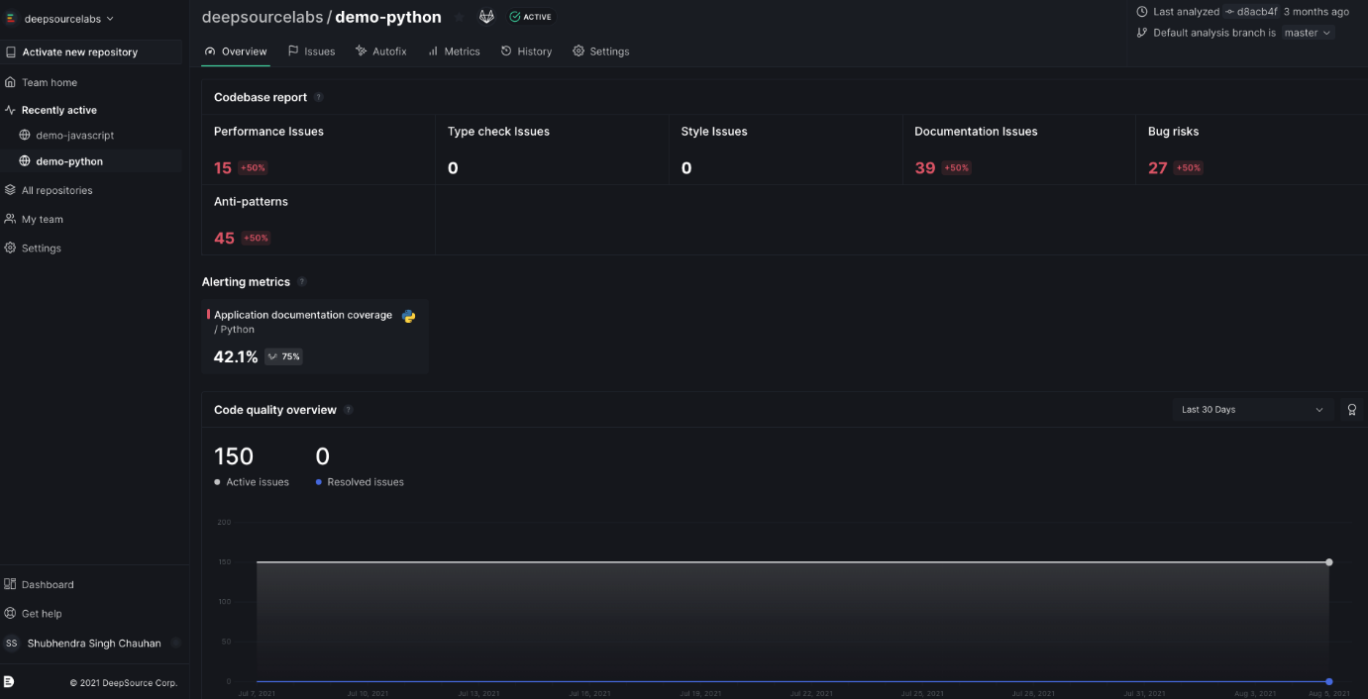

**Part C**

In this part I will be investigating the use of Basic and Advanced operators. For each operator I will give two examples of where they can be used. The examples will include when the operators are used alone and when they are used together or in combination.

**Basic Operators**

**Examples of usage for + operator**

This operator is used to include keywords.

Alone: internet + security

Combination: internet + security + application

**Examples of usage for – operator**

This operator is used to exclude keywords.

Alone: application - internet

Combination:

**Examples of usage for ~ operator**

Used to include synonyms and similar words.

Alone: internet **~**security

Combination:

**Examples of usage for . operator**

Used to include single character wildcards.

Alone: .ternet

Combination:

**Examples of usage for * operator**

Used to include single word wildcards.

Alone: internet * security

Combination:

**Examples of usage for “” operator**

Used to include exact matches.

Alone: ”internet security”

Combination:

**Examples of usage for | / OR operator**

Used to include keywords where either one keyword or another is matched.

Alone: internet OR security, internet | security

Combination:

**Advanced Operators**

**Examples of usage for Allintext operator**

Only results containing *all* of the specified words somewhere on the page will be returned.

Alone: allintext:advanced security

Combination:

**Examples of usage for allintitle operator**

Results containing *all* of the specified words in the title tag will be returned.

Alone: allintitle:advanced security

Combination:

**Examples of usage for allinurl operator**

Results containing *all* of the specified words in the URL will be returned.

Alone: allinurl:advanced security

Combination:

**Examples of usage for cache operator**

Used to search and display a version of a web page as it was shown when google crawled it.

Alone: cache:website.com

Combination:

**Examples of usage for Define operator**

A dictionary built into Google, basically. This will display the meaning of a word in a card-like result in the SERPs.

Alone: define:especially

Combination:

**Examples of usage for filetype operator**

Used to limit the search to text found in a specific file type.

Alone: mysql filetype:sql

Combination:

**Examples of usage for info operator**

Find information about a specific page.

Alone: info:security.com

Combination: info:security.com / id:security.com

**Examples of usage for intext operator**

Find pages containing a certain word (or words) somewhere in the content.

Alone: intext:security

Combination:

**Examples of usage for Intitle operator**

Used for searching a string text within the title of a page.

Alone: intitle: “index of”

Combination:

**Examples of usage for inurl operator**

Used to search for a string within a URL.

Alone: inurl:mytext.txt

Combination:

**Examples of usage for link operator**

Is used to search for pages that link to the requested URL.

Alone: link:www.website.com

Combination:

**Examples of usage for related operator**

Find sites related to a given domain.

Alone: related:security.com

Combination:

**Examples of usage for Site operator**

Used to limit the search query to a specific domain or web site.

Alone: site:website.com

Combination:

**Examples of usage for numrange operator**

Find results from a certain number range.

Alone: numrange:2-8

Combination:

**Examples of usage for daterange operator**

Find results from a certain date range.

Alone: daterange: 220899-231099

Combination:

Next, I will say whether it is possible to achieve the same results without using the operators given above.

**\*\***

Using the list of operators above I will identify if there are any equivalent operators that can be used in Bing (repeating the above exercise).

Most of these operators perform the same task when using Bing so I have not relisted them as they are the same. However, there are some operators that don’t work in Bing:

* Intext
* inurl
* related
* cache
* info
* allinurl
* allintitle
* link:
* ~

Finally, I will list ten search engines outlining their advantages and disadvantages over Google or Bing.

**Yahoo**

Advantages:

* Mail (1Tb) as opposed to googles 15GB

Disadvantages:

* Doesn’t have a book search
* No Google hangouts alternative
* No google maps alternative

**AOL**

Advantages:

* The AOL network includes many popular web sites like engadget.com, techchrunch.com and the huffingtonpost.com.

**ask.com**

google ranks their search results based on popularity but ask.com ranks their results based on a expertRank formula. The top results are determined by expertise.

Anyone can edit the search engines results.

**Baidu**

Advantages:

* Has the upper hand in China
* Baidu is [reported](http://www.chinainternetwatch.com/12678/search-engine-market-overview-2014/) to control around 80% of Chinese online search market

Disadvantages:

* Not an international search engine

**Wolframalpha**

Advantages:

* Does calulations. for example if you enter “mortgage 2000” as input it will calculate your loan amount, interest paid etc.

**DuckDuckGo**

Advantages:

* it is not fully loaded with ads
* DuckDuckGo(DDG) does not collect any information about the user, no search history, IP address or cookies

**Internet Archive**

Advantages:

* It is very useful tool if you want to trace the history of a domain.

**Yandex.ru**

Advantages:

* Yandex is a portal.
* Yandex is better for Russian language search
* It is popular on android

**Firefox**

Advantages:

* Tweakable interface and settings
* User-friendly features
* Open Source

**Opera**

Advantages:

* Hackers spend less time trying to infiltrate Opera.

**Part D**

1. **Injection**

Injection flaws are when an attacker uses unfiltered and often [malicious data to attack databases or directories connected to your web apps](https://owasp.org/www-community/Injection_Flaws). Two common injection attacks often get used. First, SQL injection gets used to attack your databases. Second, LDAP injection gets used to attack directories.

Injection attacks use input fields that interact with directories and databases to execute against vulnerabilities. These include usernames, passwords, and other areas that interact with the target. These fields are often left vulnerable due to the lack of an input filter when the database or directory’s development.

1. **Broken Authentication**

Authentication helps apps identify and validate users. Therefore broken authentication can allow attackers to access and have the same permissions as the targeted user, creating severe web app vulnerabilities. Issues with authentication can give an attacker unfettered access to your data and wreak havoc on your web application.

Authentication vulnerabilities can include improperly hashed and salted passwords, leaks involving user account data, improperly set timeouts, brute force attacks,  or typical password stuffing like password1 or admin1234.

1. **Sensitive Data Exposure**

Sensitive data gets transported or stored without any encryption or other protection, leaving information vulnerable to various attacks.

There are two ways to attack unprotected data. First, while data is transported from the user to the client, attacks as a man-in-the-middle attack can be used to steal data from packets. Second, stored data, while more complicated, can be exposed through encryption keys get stored with data or weak salt/hash or passwords and credentials.

1. **Broken Access Control**

When server-side authorization is misconfigured, broken, or missing, vulnerabilities will occur that can leave your back-end open to attacks.

These attacks often happen with front-end UIs configured with components to give admins access to data or other vital app elements. In this case, most users can’t see the admin function, but those looking to find vulnerabilities will be able to uncover and exploit this flaw with malicious requests.

1. **Security Misconfiguration**

Often web applications are misconfigured, leaving an array of vulnerabilities for attackers to capitalize. Security misconfigured vulnerabilities can include unpatched flaws, unused pages, unprotected files or directories, outdated software, and running software in debug mode.

All aspects of your web applications can be affected by security misconfigurations. When a misconfiguration is found, it is vital to run a security audit to check for attacks or breaches.

1. **Cross-Site Scripting**

Cross-site scripting uses malicious code injected into benign sites to attack a user’s web browser. An attacker will insert the code through a link and, together with social engineering, will lure the user to clicking the link and executing the code. Attackers using JavaScript for XSS vulnerabilities can access a user’s webcam, location, and other sensitive data and functions.

XSS vulnerabilities are common where input is unsanitized. Additionally, XSS can allow attackers to [steal cookies from users’ browsers](https://pentest-tools.com/blog/xss-attacks-practical-scenarios/)and access browsing history and sensitive information.

1. **Insecure Direct Object References**

When database keys or files get exposed to the user, insecure direct object reference vulnerabilities exist. Because of the exposed internal objects, attackers can use enumeration attacks to access those objects and gain data or access to sensitive databases. Often authentication is either non-existent or broken.

Database objects are often vulnerable through URL parameters exposing serialized data keys an attacker can manipulate to access information. Also, static files can be manipulated and changed by an attacker to access sensitive information or other user’s data.

1. **Cross-Site Request Forgery**

Cross-site request forgeries (CSRF) use social engineering to trick authenticated users into clicking a link, as an example and take control of their sessions. Due to having authenticated sessions, the attacker can perform changes to the state of an app vs. data theft.

Applications without the proper dual authentication or cross-site tokens can be vulnerable to CSRF attacks. Those will little knowledge of social engineering are also at higher risk of their authenticated sessions hijacked.

1. **Using Components with Known Vulnerabilities**

Due diligence needs to get done when considering using a third-party code or component in your web application. Many security issues can come with using unfettered code from sources you aren’t familiar with.

To help find what components may be vulnerable, the [National Vulnerability Database](https://www.nist.gov/) has a comprehensive list of known third-party vulnerabilities to help make the best choice.

Every aspect of your app can be affected by vulnerabilities in third-party code. For example, backdoors can get added to financial services code allowing attackers access to sensitive data.

1. **Insufficient Logging & Monitoring**

Unvalidated redirects and forwards is another input manipulation vulnerability again using parameters like GET requests to execute the attacks.

An example of the vulnerability is an attacker manipulating a URL and redirecting users to a malicious site where information can get stolen using social engineering and links with malicious code or links.